**Experiment No.: 2**

**Title:** Virtual Lab on Sampling theorem and Reconstruction techniques

**Batch: B1 Roll No.: 1914078 Experiment No.:2 Aim:** Explore the virtual lab on Sampling theorem and Reconstruction techniques.

Resources needed: Virtual Lab

Introduction:

This experiment enables a student to learn .How to view the real life analog signal with an oscilloscope. How to set the amplitude, frequency and phase of the signal source. How to set the sampling frequency of the source such that the signal is exactly reconstructed from its samples. The principal objective of this experiment is to understand the principle of sampling of continuous time analog signal.

Theory:

The signals we use in the real world, such as our voices, are called "analog" signals.  To process these signals in computers, we need to convert the signals to "digital" form.  While an analog signal is continuous in both time and amplitude, a digital signal is discrete in both time and amplitude.  To convert a signal from continuous time to discrete time, a process called sampling is used.  The value of the signal is measured at certain intervals in time. Each measurement is referred to as a sample. The Sampling Theorem states that a signal can be exactly reproduced if it is sampled at a frequency F, where F is greater than twice the maximum frequency in the signal. When the continuous analog signal is sampled at a frequency F, the resulting discrete signal has more frequency components than did the analog signal. The process of digitization consists of first sampling (digitization in time) and quantization (digitization in amplitude). The sampling process depicts an analog signal as a sequence of values. An ideal sampler can be considered as a switch that periodically opens and closes every T seconds. The sampling frequency (fs in Hertz) is thus defined as

fs=1T....(1)

The sampled discrete time signal x(nT) , n=0,1,2,.... of the original continuous time signal x(t) is shown in Fig. 2 below.

In order to represent an analog signal x(t) by a discrete-time signal x(nT) accurately, so that the analog signal can be exactly reconstructed back from the discrete-time signal, the sampling frequency fs must be at least twice the maximum frequency component (fM) of the original analog signal. Thus we have,

fs≥2fm....(2)

The minimum sampling rate is called the Nyquist rate and the above Sampling Theorem is called the Shannon's Sampling Theorem. When an analog signal is sampled at fs , frequency components higher than fs/2 fold back into the frequency range [0, fs/2]. This folded frequency components overlap with the original frequency components in the same range and leads to an undesired effect known as aliasing.

**Activity:** Search IITK virtual lab, study and write some primary observation. Complete the writeup.

**Questions:**

Q1. If the information signal is of 4KHz, what should be the minimum sampling frequency?

1. 8KHz

Q2. Let the information signal be 1KHz. What is the effect of using 32KHz over 2KHz as sampling frequency?

1. We will get different Yn for different N if we use sampling frequency as 32KHz whereas Yn will be 0 for all N if sampling frequency is 2KHz.

Q3. What is sampling? When do we use sampling?

1. Sampling is a tool that is used to indicate how much data to collect and how often it should be collected. This tool defines the samples to take in order to quantify a system, process, issue, or problem. To convert a signal from continuous time to discrete time, sampling is used.

Q4. State sampling theorem.

1. The Sampling Theorem states that a signal can be exactly reproduced if it is sampled at a frequency F, where F is greater than twice the maximum frequency in the signal.

Outcomes: CO4: Execute their knowledge of computer communication principles, including Error detection and correction, multiplexing, flow control, and error control.

|  |  |
| --- | --- |
| n | Y(n) |
| 0 | 0 |
| 1 | 0.78 |
| 2 | -1.54 |
| 3 | 2.26 |
| 4 | -2.93 |
| 5 | 3.53 |
| 6 | -4.04 |
| 7 | 4.45 |
| 8 | -4.75 |
| 9 | 4.93 |
| 10 | -5 |
| 11 | 4.93 |
| 12 | -4.75 |
| 13 | 4.45 |
| 14 | -4.04 |

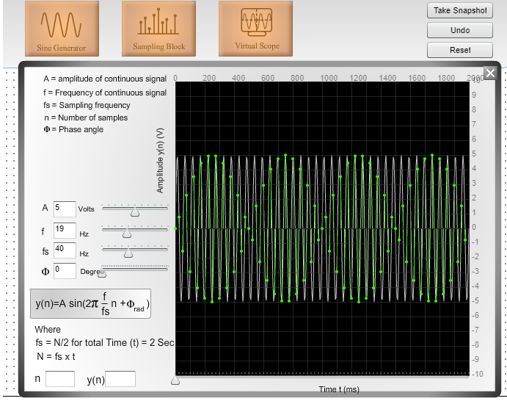

|  |  |
| --- | --- |
| n | Y(n) |
| 0 | 0 |
| 1 | -3.71 |
| 2 | 4.97 |
| 3 | -2.93 |
| 4 | -1.03 |
| 5 | 4.33 |
| 6 | -4.75 |
| 7 | 2.03 |
| 8 | 2.03 |
| 9 | -4.75 |
| 10 | 4.33 |
| 11 | -1.03 |
| 12 | -2.93 |
| 13 | 4.97 |
| 14 | -3.71 |

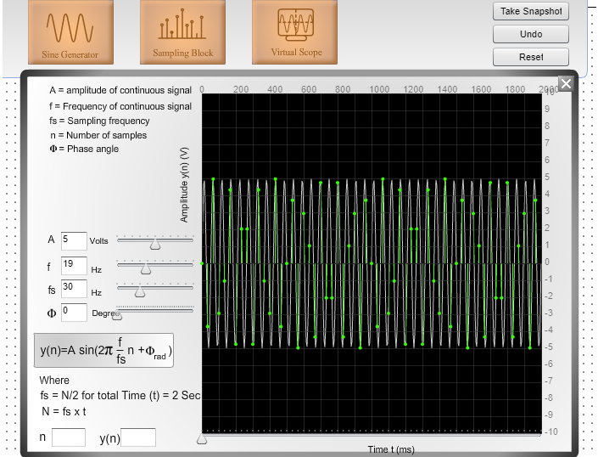

|  |  |
| --- | --- |
| n | Y(n) |
| 0 | 0 |
| 1 | 1.25 |
| 2 | -2.47 |
| 3 | 3.63 |
| 4 | -4.7 |
| 5 | 5.65 |
| 6 | -6.47 |
| 7 | 7.12 |
| 8 | -7.6 |
| 9 | 7.9 |
| 10 | -8 |
| 11 | 7.9 |
| 12 | -7.6 |
| 13 | 7.12 |
| 14 | -6.47 |

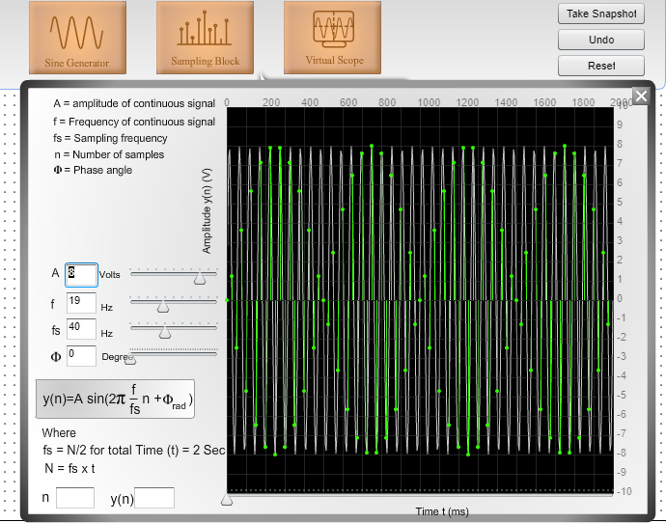

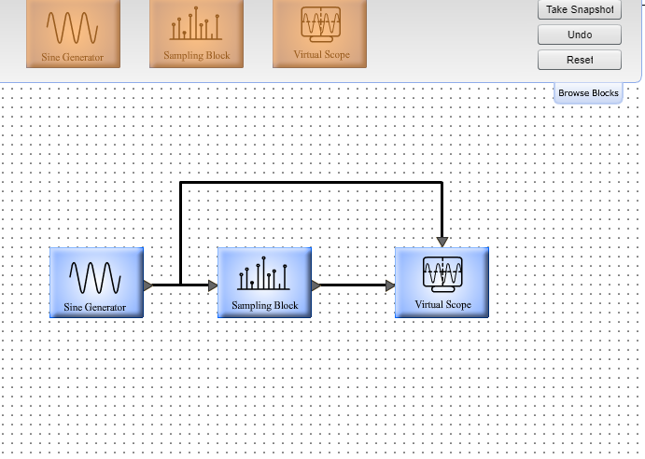



Conclusion: We observed the inter relation between sampling all the way to digitization on which the following this we will change i) fs> 2f and see the N-Yn relationship and will do the same by ii) amplitude and keeping fs>2f and one with iii) fs<2f and amplitude kept same.

Grade: AA / AB / BB / BC / CC / CD /DD Signature of faculty in-charge with date

References:

Books/ Journals/ Websites:

[Virtual Lab http://vlabs.iitkgp.ernet.in/dsp/1](http://vlabs.iitkgp.ernet.in/)